Five knowledge points:
1 what is context model? Please give an example.
- Context model is used to illustrate the operational context of a system - they show what lies outside the system boundaries. In short it defines how context data are structured and maintained.
- For example an ATM system and its environment.

2. what is Interaction models? Please give an example.
- Interaction models is defined as the function of input required by the learner while responding to the computer, the analysis of those responses by the computer, and the nature of the action by the computer.
- For example 1: Teacher and student. Student ask the teacher and the teacher answer the questions.
-Example 2: Encoding and decoding. The sender encode a message and the receiver decode a message.

3. Usually, Use case diagrams and sequence diagrams may be used for interaction modeling. Please an example for each kind of diagram.

Use Case diagrams:

Medical receptionist
Patient record system
Transfer data

Sequence diagrams:

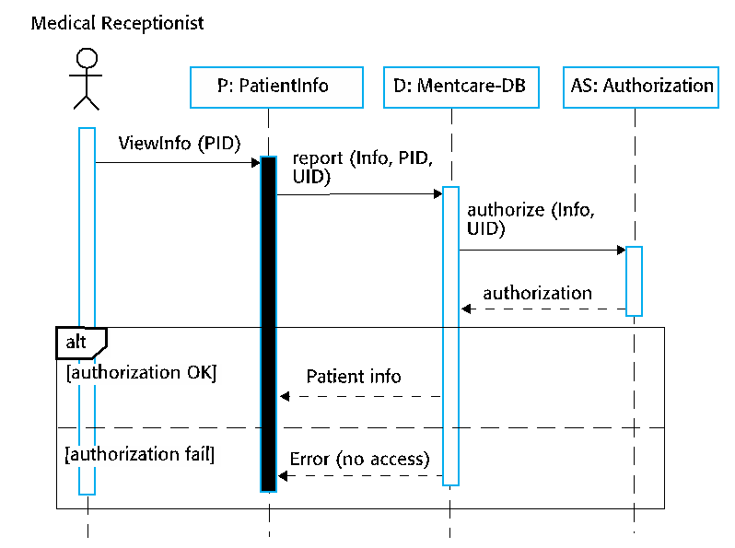

4. what is Structural models? Please give an example. Which diagrams usually can be used to describe Structural models?
- Structural models is the architectural map for a large software system or family of systems.
- It display the organization of a system in terms of the components that make up that system and their relationships.
- Diagrams which can be used to describe structural models:
- Structural diagrams
- Package diagrams
- Profile diagrams
- Class diagrams

5. what is Behavioral models? What are two kinds of behavioral models?
- Behavioral models attempts to explain why an individual makes a decisions and the model is then used to help predict future behavior.
- They show what happens or what is supposed to happen when a system responds to a stimulus/input from its environment.
2 Kinds of behavioral models:
- Data Some data arrives that has to be processed by the system.
- Events Some event happens that triggers system processing.

